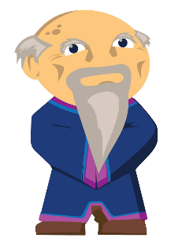**Week 1 Introducing Scratch** | **Lesson** 1.2 Explore (30 min)

*Introduce Scratch 3.0. Then students play Scratch Games on a tablet or computer.*

Links to Resources | [Overview - GBC Week 1](http://localhost/) | [Slideshow](http://localhost) |

|  |  |
| --- | --- |
| **Explore:** Introduction to Scratch | |
| 15 min | **Activity:** Introduce Scratch 3.0 Editor   1. Main Tab    1. Menus – Use the file menu to save or load files    2. Coding Aria – Drag and drop the blocks here and snap them together to create your code    3. Start and Stop – Click the green flag to start your code, or stop sign to stop    4. Block Categories – Code blocks in the Block Pallet are sorted into colored groups. Click a category to scroll to the blocks in the category    5. Stage – Your code will run here    6. Sprite List – All the sprites in your project are shown here. The selected sprite has a blue border around it    7. Backdrop – Add new background to your project 2. Costumes Tab    1. Drawing Tool - You could use this to draw on your sprite    2. Costumes – Sprite could have more than one look. Scratch calls these looks costumes. We will use different costumes to make simple animations    3. Color Sliders – We could make colors here 3. Code Blocks    1. Input Block – an input is an action that tells a computer to do something. You can use input blocks to make code run when the player does something, like pressing a key or moving the mouse    2. Motion Block – this makes a sprite move    3. Forever Block – Any code you put inside this will keep running forever    4. Next Costume Block – This tells a sprite to change the costume, making it look like it moves    5. Wait until block – this block tels what to do if something happens |
| 15 min | **Independent Practice:** Students could play some of the Scratch Games provided by the instructor or could search Scratch   1. After the majority of students have completed one a game, pause the class and give students motivation: *“Now you saw the top scratch games, how could we make them more fun? We wish that our students would take TOP 10 spots on the best Scratch Game list!”* |